“YESTERDAY, TODAY, TOMORROW ”
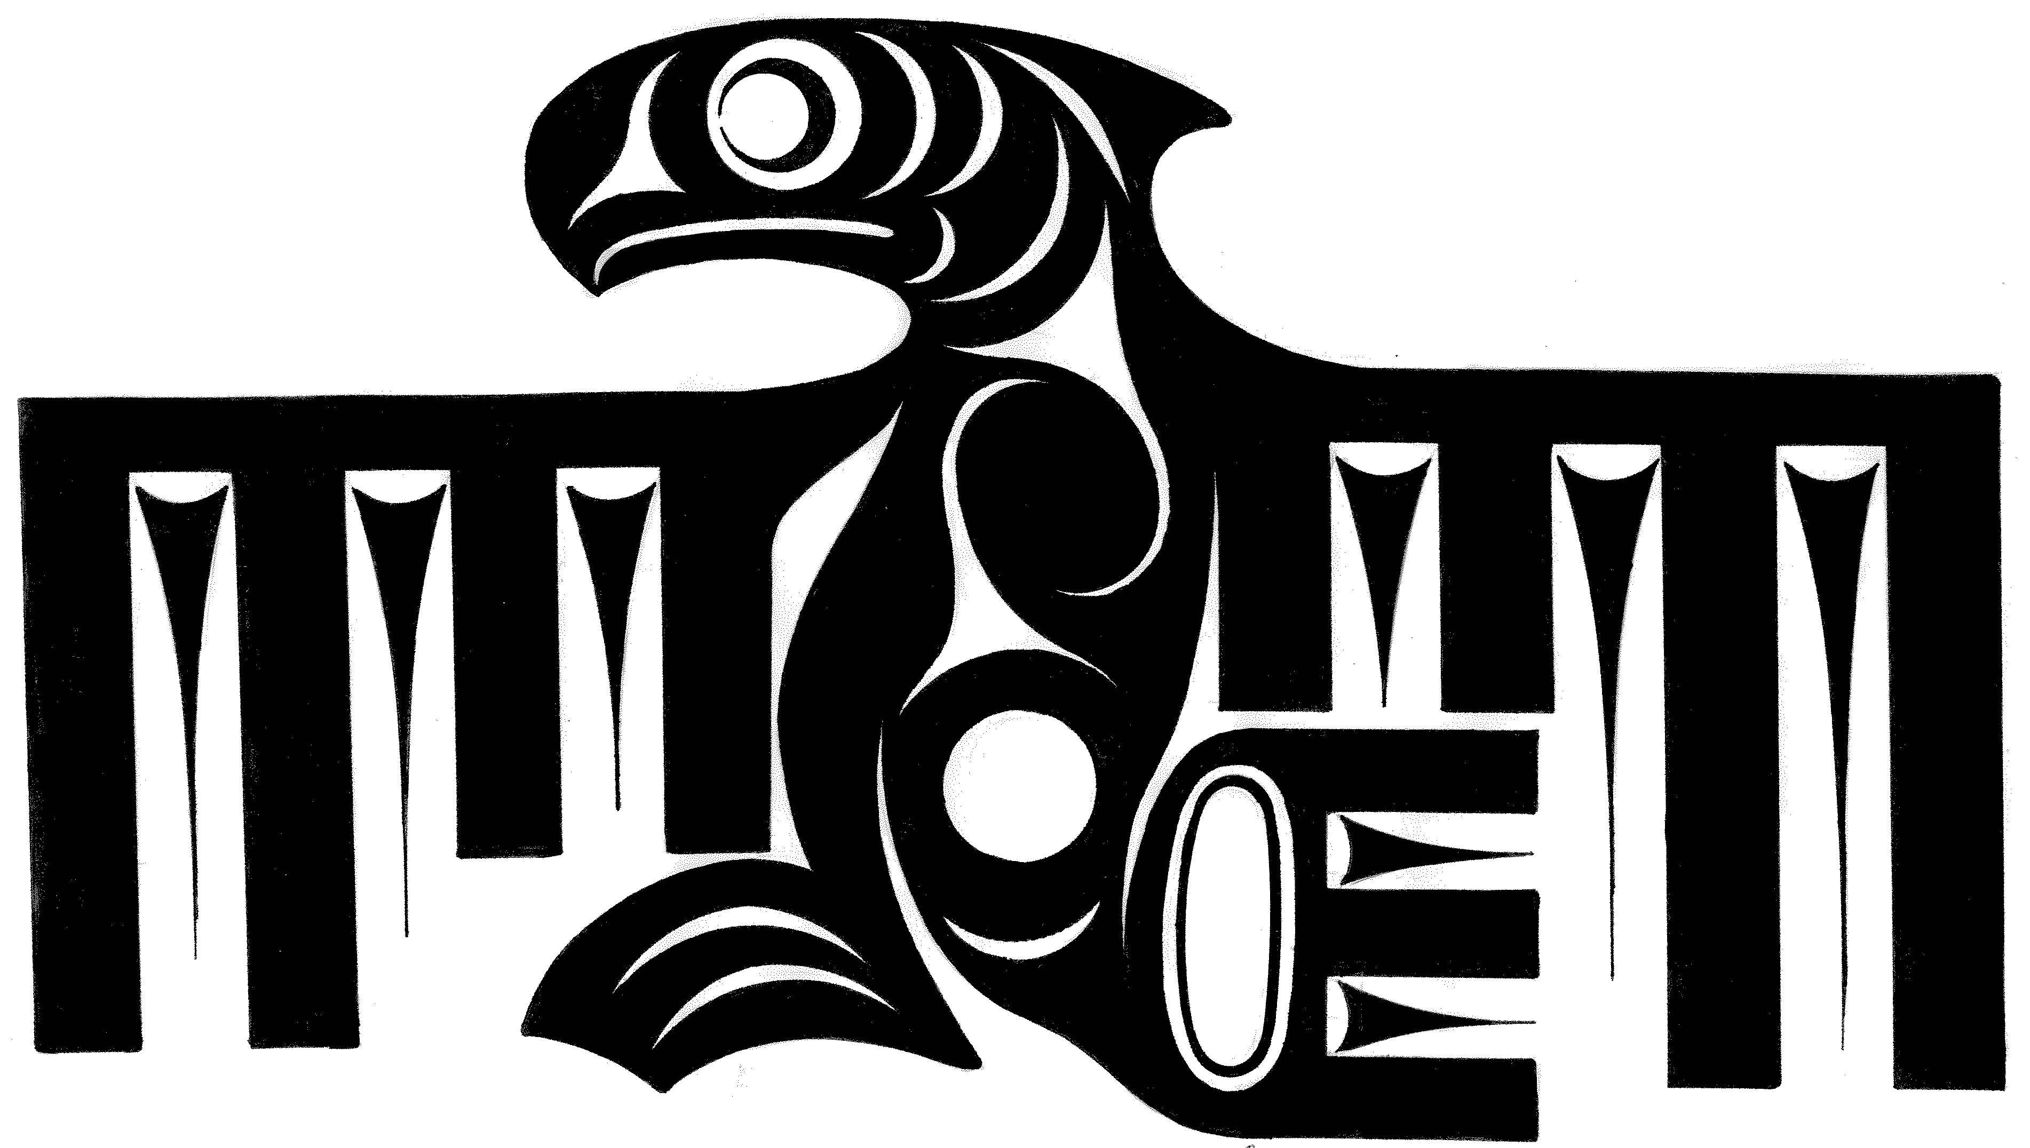
2nd Annual
Coast Salish Gathering
A Gathering of cOAST sALISHPeoples: Western Washington Tribes and bRITISH cOLUMBIA FIrst Nations of the Salish Sea
U’ w q ( United)

Introduction
Gathering of Tribes and First Nations of the Salish Sea Region

RELVENT INFORMATION
Xwe-nal-mewx Salish Nations Declaration
Joint Statement of Cooperation
Treaty of Indigenous Peoples International
Environmental Cooperation Agreement

THE GATHERING
Invitation Letter, Hul qumi’num Treaty Group and Cowichan Tribe
Honoring the Elders
Keynote and Special Speakers
Tom Sampson, Coastal Sea Imitative Saanich Inlet
Billy Frank, Chairman, NWIFC, Nisqually Indian Tribe
Fay Cowen, Professor, Dalhouse University
Clarence Alexander, Yukon River Inter Tribal Watershed Council
Harold Gatensby, Yukon River Inter Tribal Watershed Council

ORDER OF BUSINESS
Schedule of Events
2005 Coast Salish Gathering Policy Dialogue Points and Executive Summary

APPENDIX
Sponsors

Introduction
The Gathering
Tribes and First Nations of the Salish Sea Region
We have come together to share, prioritize, develop and recommend policies and actions to ensure the protection of our shared environment and natural resources in our homeland, the Salish Sea.

The Second Coast Salish Gathering Tribes and First Nations of the Salish Sea Region

We have come together to share, develop and prioritize recommend policies and actions to ensure the protection of our shared environment and natural resources in our homeland, the Salish Sea.

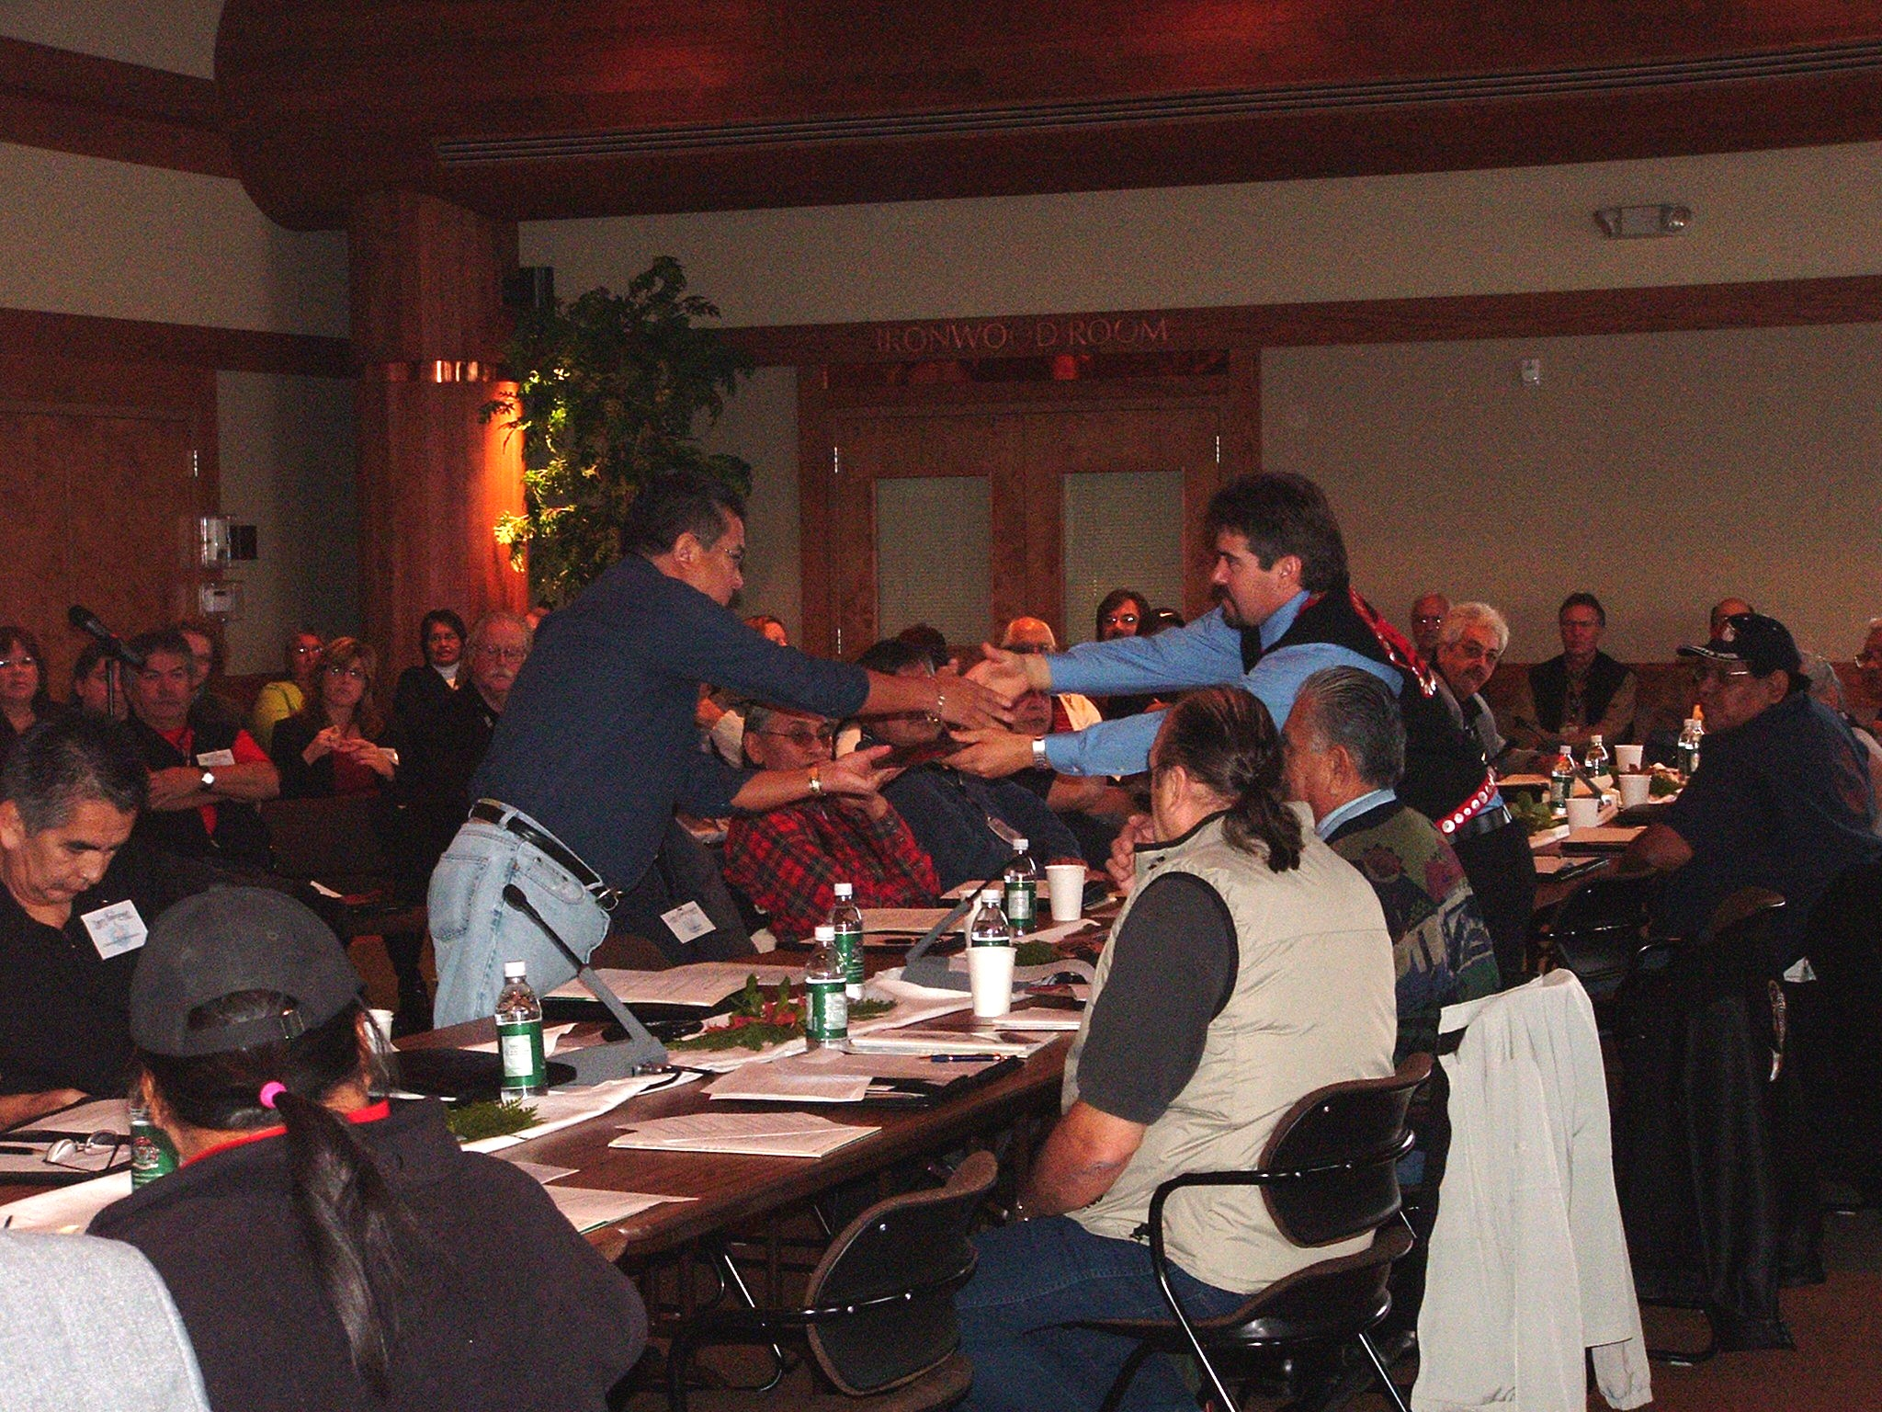
The 2005 Coast Salish Gathering initiated a dialogue regarding Tribal/First Nations environmental concerns, issues and projects in the international Trans-boundary region of the Georgia Basin/Puget Sound. Our Elders reflected on the Salish Sea of their youth and the changes they have witnessed. Our dialogue shared our aboriginal perspective on the current state and trends of the environment in this unique estuarine ecosystem that we call “home”. The objective of the Gathering was to provide a forum for Tribal and First Nations leaders to collaborate on environmental issues and share that information with governmental policy makers to assist them in making more protective decisions concerning the future of this richly endowed, yet fragile, region that we share, the Salish Sea.

Our homeland is rich in a diverse array of marine and upland resources unique to this area that sustain our cultures and traditions. Salmon are the icon of this essential and yet diminishing connection of our people to our land. Our homelands and our resources are under significant pressure from population growth, industrial expansion and economic demands. Due to the serious environmental challenges to the Salish Sea, Tribal and First Nations leaders along with Government officials engaged in a policy dialogue to come to common ground on identifying environmental issues in the shared region.

The 2007 Gathering will, once again, provide an environmental policy platform for the five government bodies of the Salish Sea Region; Tribal, First Nations, State, Provincial and Federal, to discuss the various treaties, agreements and polices that protect the environmental of the Salish Sea Ecosystem, as well as the implementation of various actions and recommendations from the existing environmental policies, agreements and treaties affecting the Salish Sea.

Our first day of the Gathering will rekindle the relationship of Coast Salish First Nations and Tribes through our traditional practices. The ceremonies are an important traditional process that is valuable in unifying the gathering that will include the introduction of a Partnership Signing Ceremony; where all five governments will be asked to come together with one common goal; “to protect the environment of the Salish Sea”.

The Plenary Session, the second day, will provide the Coast Salish people a “podium” to share a unified aboriginal perspective on the current state and of the Salish Sea environment including recommendations for protection of this unique estuarine ecosystem that we call “Home”. The objective is to provide a forum for Tribal and First Nations leaders to collaborate and speak with “One Voice” on environmental issues. This dialogue provides an opportunity to share information and recommend actions to policy makers with a goal of assisting them in making policy decisions that are more protective concerning the future of this richly endowed yet fragile region that we share.

The Gatherings are an outgrowth of the Joint Statement of Cooperation between Environment Canada (EC) and the United States Environmental Protection Agency (EPA) to collaborate on a shared responsibility to protect the region known as the Georgia Basin/Puget Sound. Below is a section out of the existing plan; the Statement is included in a section dedicated to including Aboriginal Peoples into these efforts.

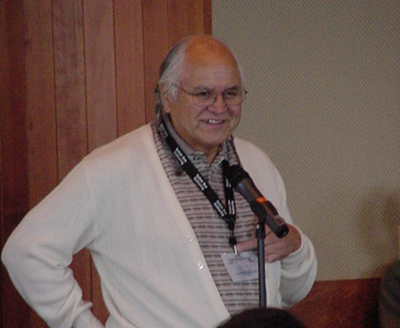
“… the Aboriginal people of the Georgia Basin and the indigenous inhabitants of Puget Sound have a special role to play in the future of the ecosystem.”
The Aboriginal people of the Georgia Basin and the indigenous inhabitants of Puget Sound have been stewards of the lands and resources in the Georgia Basin/Puget Sound region since time immemorial. And their knowledge, talents and energy should be part of the region’s future.
To preserve and protect the region, we should work closely with representatives of the Aboriginal people of the Georgia Basin and the indigenous inhabitants of Puget Sound in an atmosphere of mutual respect so that their special knowledge and unique perspective can contribute to our common efforts.”
Ernest George, Tsleil Waututh Nation

This section of the Joint Statement of Cooperation is the birth of the Gathering; and EPA’s and EC efforts to hear and respond to Tribal and First Nation’s issues and recommended issues in our homelands.
JOINT STATEMENT OF COOPERATION ON THE
GEORGIA BASIN AND PUGET SOUND ECOSYSTEM
by the Minister of Environment Canada and the Administrator of the United States Environmental Protection Agency
We see a special place …
… where people of all ages can breathe clean air, drink clean water, swim on clean beaches, and enjoy unparalleled vistas of mountain, ocean and shore.
… where the integrity of wilderness is protected and the future of forests, wildlife, fish and marine mammals is secure.
… where the traditional values and knowledge of the Aboriginal people of the Georgia Basin and the indigenous inhabitants of Puget Sound are honored and applied to new challenges.
... where our common goal of sustainable communities – embracing human well-being, economic opportunities and environmental quality – can be realized by today’s generations and by those yet to come.
We believe that …
… the Georgia Basin/Puget Sound ecosystem is a unique and special place.*
The Georgia Basin/Puget Sound ecosystem is one of the most diverse regions of North America: diverse in its ecology, in its landscape, and in its peoples.
A spectacular mountain and island landscape dominated by a bountiful inland sea, the ecosystem provides vital habitat for millions of birds that migrate each year along the Pacific Flyway. Its waters are home to five species of spawning salmon, whales, seals, and a rich variety of fish.
A hub of global trade and commerce, the region is a multicultural home to nearly 6 million people, drawn by the superb quality of life offered by the region – the beauty of the landscape and ocean, the mild climate, a richness of resources, and employment and investment opportunities. The region supports a wide range of agricultural, forestry, fishing, manufacturing, and recreational and tourism activities.
*For the purpose of this Statement, the term “Georgia Basin” refers to that portion of the ecosystem located in Canada, and the term “Puget Sound” refers to that portion of the ecosystem located in the United States.
… the future of the Georgia Basin/Puget Sound ecosystem is threatened.
We cannot take the future of the ecosystem for granted.
The region’s economic wealth has long been based on its abundant natural resources. Today, however, rapid population growth and associated human activities threaten the natural environment, which has made the region so special and attractive.
In the past 25 years, the population in the Georgia Basin/Puget Sound ecosystem has more than doubled. In the next 15 years, it may double yet again, creating enormous pressures on the economy, society and environment of the region.
With rapid population increases, rich agricultural land is lost to housing and roads, wildlife habitat is lost or destroyed and some species are put at grave risk. More people have meant more cars, more vehicle emissions and lower air quality, more garbage, more sewage and more water pollution.
Concern for the future of the ecosystem does not arise from activities within the region alone –the region cannot escape the impacts of changes in the global environment. Of special concern is the potential for global changes in atmosphere and climate to affect the fragile and interwoven features of the Georgia Basin/Puget Sound ecosystem. Changes in rainfall patterns, for example, could affect agricultural production and the health of forests; warmer oceans could severely reduce fish stocks. Over time, climate change could affect human health and safety.
… it is not too late to save the ecosystem for our children and for their children.
We have today an opportunity for action as unique as the ecosystem itself. All the necessary factors for a successful ecosystem-wide effort are in place. Governments and the general public are aware of the many challenges to the ecosystem. We have the desire to preserve this special place. The sound science we need to make informed policy choices is at hand. The commitment to cooperation and partnerships is stronger than ever.
… protecting this special place is our shared responsibility.
With this Joint Statement of Cooperation, we are acting on the two federal governments’ unique responsibilities to address the Tran boundary and global environmental challenges confronting the future of the ecosystem. But we cannot fulfill our shared vision of a healthy, sustainable ecosystem on our own.
The challenges ahead – from climate change to clean beaches, from urban smog to clean drinking water – are simply too complex and interconnected for any one level of government or any one country to resolve on its own.
All residents of the region, in Canada and in the United States of America, and all levels of their governments, share responsibility for protecting and enhancing the integrity and viability of the ecosystem, so that this special place can be enjoyed by present and future generations.
We should find ways to work together on these shared concerns. We should engage the considerable skills, energy and resources of local and regional governments, community groups, educators, youth, workers, industry and business.
… the Aboriginal people of the Georgia Basin and the indigenous inhabitants of Puget Sound have a special role to play in the future of the ecosystem.
The Aboriginal people of the Georgia Basin and the indigenous inhabitants of Puget Sound have been stewards of the lands and resources in the Georgia Basin/Puget Sound region since time immemorial. And their knowledge, talents and energy should be part of the region’s future.
To preserve and protect the region, we should work closely with representatives of the Aboriginal people of the Georgia Basin and the indigenous inhabitants of Puget Sound in an atmosphere of mutual respect so that their special knowledge and unique perspective can contribute to our common efforts.
… we can build on the real progress made to date.
In our efforts to work closely together for the future of the Georgia Basin/Puget Sound ecosystem, we intend to build on the many worthwhile cooperative initiatives and excellent working relationships that have been established in the region. These include a range of existing Canada-United States arrangements, and multi-party initiatives led by governments, the Aboriginal people of the Georgia Basin and the indigenous inhabitants of Puget Sound, universities and community-based organizations. In particular, we intend to collaborate with our partners on the Washington-British Columbia Environmental Cooperation Council to establish priorities and deliver environmental results in the ecosystem.
We believe in …
… the need to translate words into actions.
Governments can serve as a catalyst for translating goals into practical, on-the-ground, in-the-air, and in-the-water actions that will preserve and enhance the Georgia Basin/Puget Sound ecosystem. Immediate actions by our governments can lend momentum to wider efforts.
… the value of working at the community level.
We believe that a successful effort to preserve and enhance the future of the Georgia Basin/Puget Sound ecosystem should be founded on action at the community level.
We believe that concerned residents and organizations in the regions are among the best sources of information on the current challenges facing the ecosystem, and that they should be partners in efforts to shape the future of their region. They should have opportunities for providing input into government planning and decisions, and for participating in activities in their communities.
… working through partnerships.
We recognize the need to work on our common goals through effective partnerships that involve open communication, a commitment to cooperate, and the use of our individual strengths and capabilities.
We intend to …
… actively work together on meeting common challenges for the future of the Georgia Basin/Puget Sound ecosystem.
Through this Joint Statement of Cooperation, we state our formal commitment to build on our long-standing and productive relationship to work cooperatively on our common vision for the Georgia Basin/Puget Sound ecosystem.
The Joint Statement of Cooperation serves as a statement of our shared principles, goals and challenges. We intend to establish common priorities and better coordinate many of the exciting initiatives already underway and provide a framework for collaboration on future initiatives in the region.
Our immediate priorities for action should be the ones that residents across the region have consistently identified as their most serious concerns: clean air, clean water, the protection of habitat and species, and sustainable communities.
… translate our commitments into annual Action Plans.
To put into practice the goals and spirit of this Joint Statement of Cooperation, we intend to establish a joint Environment Canada-Environmental Protection Agency working group of senior-level officials. The goals of this group would be to develop annual Environment Canada-Environmental Protection Agency Action Plans to share scientific information on the ecosystem, develop joint research initiatives, ensure coordination of environmental management initiatives, and jointly consider longer term planning issues, such as air quality and climate change.
… involve residents and communities concerned about the future of this special place.
We intend to provide meaningful opportunities for all residents of the Georgia Basin/Puget Sound ecosystem to participate in efforts to preserve and enhance the environmental quality and sustainability of their region.
Many worthwhile, proven cooperative mechanisms are in place in the region, both at the community and basin-wide levels. We intend to work through these cooperative mechanisms to the fullest extent possible to inform and involve local and regional governments, community groups, educators, youth, workers, industry and business. This will help ensure an open and transparent process of establishing priorities, identifying opportunities for effective cooperative action, and measuring progress.
We also intend to involve the Aboriginal people of the Georgia Basin and the indigenous inhabitants of Puget Sound through their traditional approaches for informing their peoples and making decisions.
… continually monitor our progress and address emerging challenges.
In seeking to preserve and enhance the Georgia Basin/Puget Sound ecosystem, we intend to work together in an open and accountable manner, and jointly monitor our progress and consider new priorities for action.
An annual Future of the Basin Conference, with participation from organizations and groups involved in Tran boundary initiatives in the Basin, could be an effective means of sharing information on progress and building consensus around emerging challenges.
Finally, we intend to meet on an annual basis to review progress under this Joint Statement of Cooperation and provide direction on future priorities.

Other Related Treaties, Agreement and Policies

The protection of the Salish Sea includes various declarations, policies, agreements and treaties at the five govnernmental levels: the Coast Salish Nations, Tribes, Federal, State, and Provincial.

The various policy tools are a reflection of the commitment of the five government bodies at various levels.

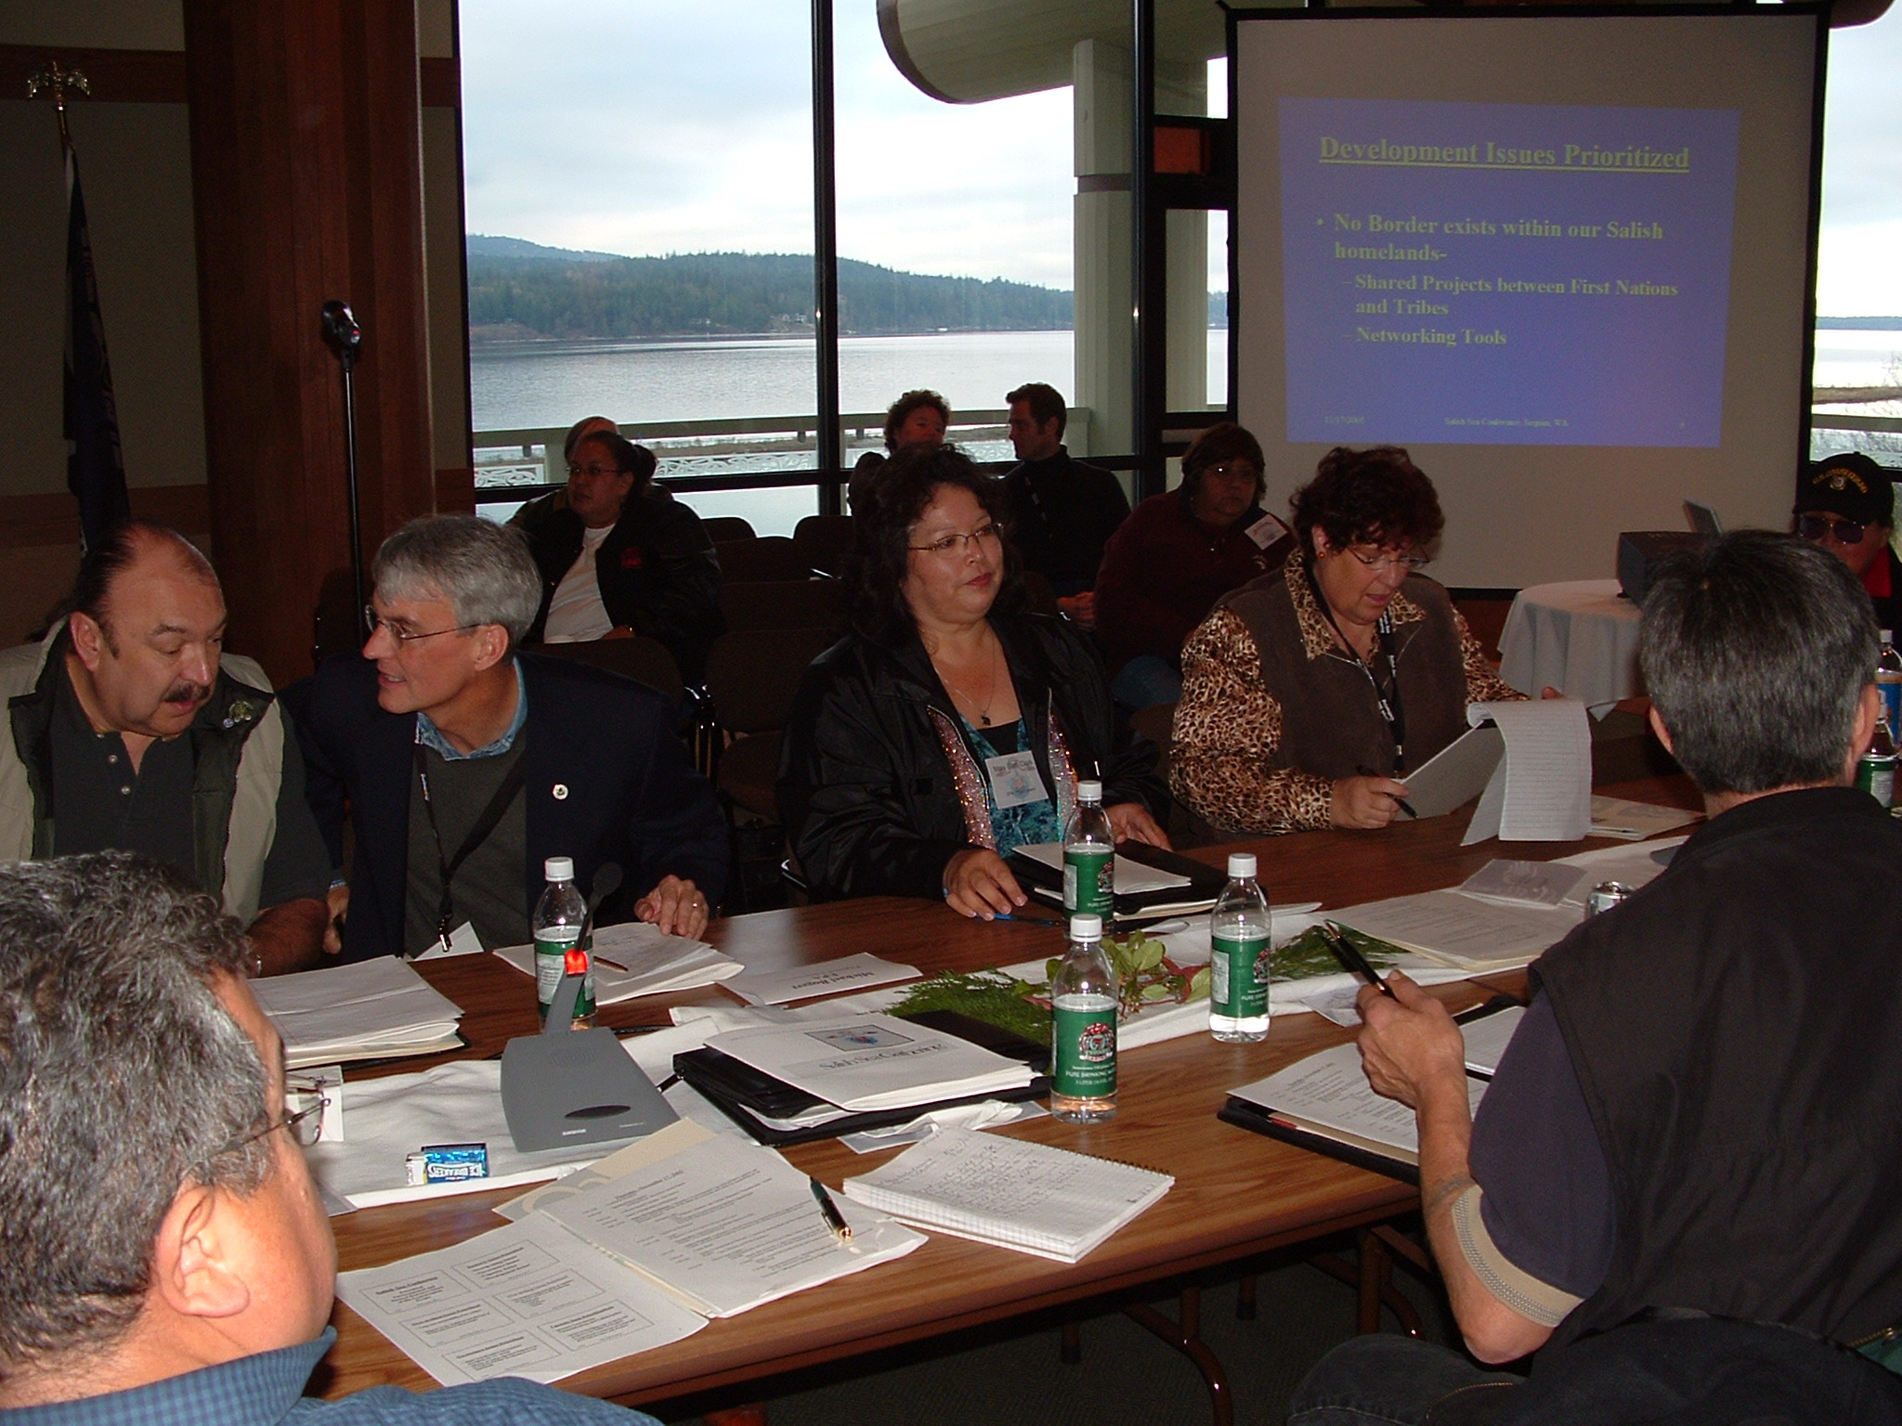
Terry Williams, Tulalip Tribes, Michael Bogert, 2006 EPA Regional Administrator, Marybeth Clark, Senior Tribal Policy Advisor, EPA Region X, Marybeth Berube, Georgia Basin Coordinator, Environment Canada

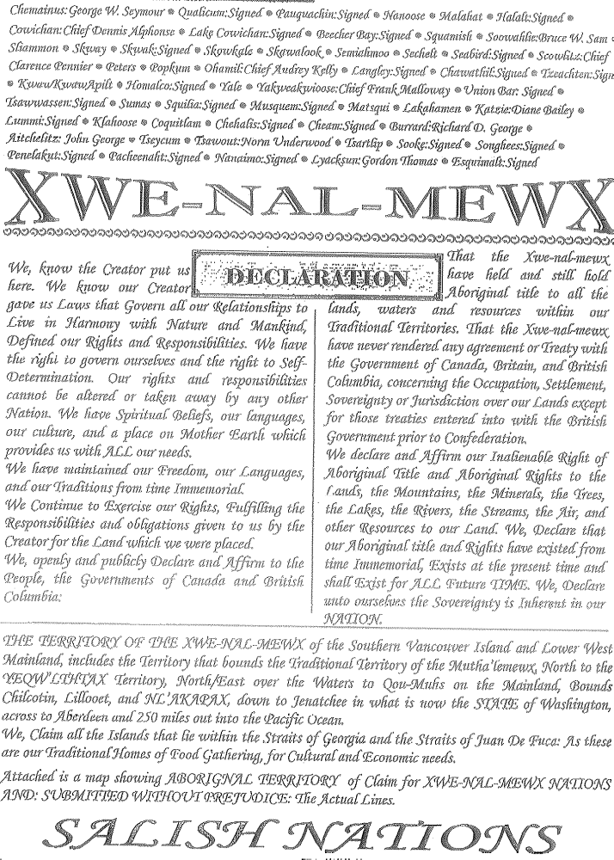

TREATY OF INDIGENOUS PEOPLES INTERNATIONAL
TIPI Treaty

PREAMBLE

Indian Nations, Tribes, First Nations, Indigenous Nations and Indigenous Peoples of the Pacific Basin, hereafter referred to as Nations, signatory to this Treaty in mutual recognition of our inherent sovereign powers, hereby re-establish political, social and economic relations, and cooperative control of natural resources essential to the cultural, spiritual and religious rights of our peoples.

PRINCIPLES

Recognizing each other as self-governing Nations, we subscribe to the following principles:
A. The Creator has made us part of and spiritually inseparable from the environment. This truth brings us together.
B. We share a cultural legacy of natural conservation and protection stemming from our inherent obligation to protect the land, water and natural resources within our traditional territories.
C. The relationship between the Nations predates colonization and will continue forever.
D. No State, Province or Nation-State is possessed of jurisdiction over any of our Nations, our peoples, or our traditional territories, except in accordance with the freely expressed wishes of that Nation.
E. We have permanent control and enjoyment of our territories, waters and the resources therein.
F. We have the sole right to control our culture, including archeological, historical and sacred sites, artifacts, designs, knowledge, and works of art.
G. We have the right to control our economics including entering into agreements regarding trade and commerce.

COMMON OBJECTIVES

This Treaty seeks to achieve the following objectives:
A. To strengthen the cooperative and supportive bond between each Nation in order to promote the rights of our peoples for the well being of all our future generations.
B. To develop an effective and meaningful process to promote cooperation between the Nations on common issues, concerns, pursuits and initiatives.
- To enhance communication and the sharing of information between the Nations.

MUTUAL COVENANTS

We are committed to provide mutual assistance on the following basis:
Each Nation shall, to the best of its ability, exchange financial, economic, legal, political, and technical knowledge regarding common issues, pursuits, or initiatives.

Each Nation shall, to the best of its ability, do the following:

(1) appoint a coordinator to implement the Treaty;
(2)coordinate statements of policy and information of mutual and general concern to be disseminated to the media;
(3)establish an inter-tribal communication network;
(4)coordinate periodic reviews and strategy planning sessions to provide direct instruction or advice on additional commitments or follow up actions.

AMENDMENTS TO THIS TREATY

Any ratifying Nation may request an amendment to this Treaty. This Treaty may be amended at a special conference called for this purpose. Any amendment shall be subject to ratification by the customary or constitutional processes of each ratifying Nation. Unanimous consent of the ratifying Nations is required to amend this Treaty.

RATIFICATION

This Treaty shall come into force when the following Nations formally ratify the provisions according to their customary or constitutional processes. Following the coming into force of the Treaty, any other Nation may ratify this Treaty at their pleasure, with the consent of Nations already signatory to this Treaty.

Each Nation which ratifies this Treaty may place conditions on its participation. Each ratifying Nation may attach a Statement of Reservations indicating specific provisions of this Treaty, which shall apply to it under specific conditions. Each ratifying Nation may attach explanations or clarifications expressing different meanings associated with the provision through a Statement of Understandings. These Reservations of Understandings shall become a part of this Treaty and receive full respect by other ratifying Nations. Signed on behalf of the Nations on September 30, 1994, at the Sqamish. And amended on June 11, 1997, at Kona, Hawai’i

- 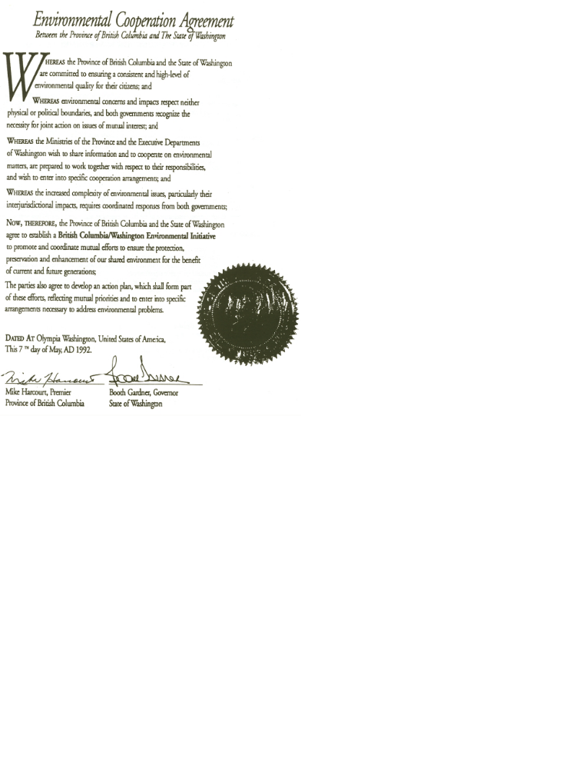

ECC: BRITISH COLUMBIA/WASHINGTON ENVIRONMENTAL INITIATIVE

Terms of Reference

Mandate/Purpose:

The Initiative’s mandate is derived from the Environmental Cooperation Agreement between the two jurisdictions entered into in May 1992. The Initiative’s purpose is to ensure coordinated action and information-sharing on environmental matters of mutual concern.

Members: Deputy Minister, BC Environment, Lands and Parks

Director, Washington Department of Ecology

Observers: Regional Director General, Pacific and Yukon Region, Environment Canada Administrator, Region 10, US Environmental Protection Agency

Support: Administrative support will be provided by BC Environment, Lands and Parks and the Washington Department of Ecology who will be jointly responsible to prepare agendas, ensure appropriate attendance at Initiative meetings and coordinate follow-up action.

Procedures:
■ The Initiative will generally meet twice each year, or as necessary.
■ The Initiative may establish sub-committees to deal with specific matters.
■ The Initiative may, by formal agreement, establish Task Forces to address issues of special or major significance.
■ An Annual Report will be made to the Premier of British Columbia and the Governor of Washington.

ECC: BRITISH COLUMBIA/WASHINGTON ENVIRONMENTAL INITIATIVE

Preliminary Action Plan/Work Priorities
British Columbia and Washington’s commitment to cooperative efforts on environmental matters has resulted in the identification of the following priority issues for action:

1. Georgia Basin/Puget Sound Water Quality Initiative
Georgia Basin/Puget Sound water quality is considered to be a high priority issue and requires immediate joint attention. Concerted efforts are underway by both governments to identify and remedy pollution problems in the Georgia Basin and Puget Sound. Coordination of these programs will enhance their environmental benefits.

2. Columbia River/Lake Roosevelt Water Quality
Columbia River/Lake Roosevelt Water Quality is considered to be a high priority issue by both parties and requires immediate joint attention.
A task force involving affected interest groups will examine the issues and ensure necessary action is taken to control sources and protect water quality.

3. Nooksack River Flooding
Nooksack River flooding is considered to be a high priority issue and requires continued joint attention. Recent flooding in Washington’s Nooksack River resulted in flooding in British Columbia’s West Sumas area. Continued attention is needed to ensure implementation of the recommendations of a Task Force that identified actions needed to avert recurrence of such problems.

4. Regional Air Quality Management
Regional air quality management is considered to be a high priority issue in the Georgia Basin/Puget Sound airshed and requires timely joint attention.
Issues such as transboundary flows of sulphur dioxide, nitrogen oxides and volatile organic compounds should be addressed in an integrated manner through regional implementation of the Canada/U.S. Air Quality Agreement. 2

5. Coordinated Groundwater Management (Sumas-Abbotsford)
Management of the groundwater in the Sumas-Abbotsford area is considered to be a high priority issue and requires immediate joint attention.
The aquifers are of particular concern as a result of domestic use on both sides of the border. Improved coordination of the activities of all parties to address both groundwater quantity and quality will encourage more effective resolution.
6. Solid, Hazardous and Biomedical Waste Cooperation
Waste management is considered to be an emerging issue and should be the subject of information exchange and further discussion. The transboundary impacts of waste management practices and contaminated sites should be examined through mechanisms such as the Memorandum of Understanding on Hazardous Waste Management.

7. Water Resource Management
Water management in general is considered to be an emerging issue and should be the subject of information exchange and further discussion.
Increased water use in response to growing needs necessitates protection of instream flows; this requires sound data and thorough field investigations. Joint efforts can ensure efficiency and maximum productivity for both governments.

8. Wetlands Protection
The protection of wetlands and wildlife habitat is considered to be an issue of ongoing interest to both parties. The exchange of information on wetland and habitat protection programs will form the basis for initial cooperation on this issue.

9. Other Issues
The parties agree to use the Initiative to identify and address issues of concern, and will assist each other in dealing with the agencies and departments of their respective governments. Potential issues for discussion include: earthquake and emergency preparedness and State of Environment reporting.

THE GATHERING
Invitation NOTE

Dear Invitees,
It is my honor, on behalf of the Hul’qumi’num Treaty Group, to invite you to the second Coast Salish Gathering scheduled for January 24, 25 and 26, 2007. This Gathering will take place at the Quw’utsun’ Cultural Center in Duncan, Vancouver Island, B.C. We will follow the format of the First Coast Salish Gathering held in November 2005 at Jamestown S’Klallam, Washington.
We will come together as Coast Salish people to speak with one voice for the preservation of our culture and the protection of the land and waters of our aboriginal homeland. As brothers and sisters with a shared culture in an endangered eco-region, we will continue our dialogue on the need for strengthened environmental policies and practices in our homelands.
In 2005, at the first Coast Salish Gathering in Jamestown, the leadership moved to form a Coast Salish Aboriginal Council that could speak as one to the environmental issues of our Culture and our aboriginal homeland. We invite you to come to our table in January to continue our policy to discuss common actions that affect our culture and common priorities.
This important invitation represents our respect for your role as a leader and policymaker in the environmental community. We value your participation and believe it will contribute to a successful outcome to the dialogue. As a policymaker, we are hoping your role at our gathering will be to hear all issues and concerns and to collaborate with us on these issues. As leaders and protectors of our shared homeland, we strive to establish a policy dialogue that will generate actions to ensure the protection of our shared ecosystems. We need a vision for the future, and we look forward to your input and experience.
Sincerely,




Chief Lisa Shaver Chief Harvey

Chief Harvey Alphonse
President of the Hul’qumi’num Cowichan Tribes
Treaty Group Board of Directors

Honoring the Elders
A Walk Through Our Past

We often look to our elders for their wisdom and their guidance; ensured when they speak it is from the heart and holds only the truth. They bring to us their thoughts and experience from their lives that only one can imagine. Our honored elders have long been our teachers and we rely on them for honesty, truth and guidance in our lives.
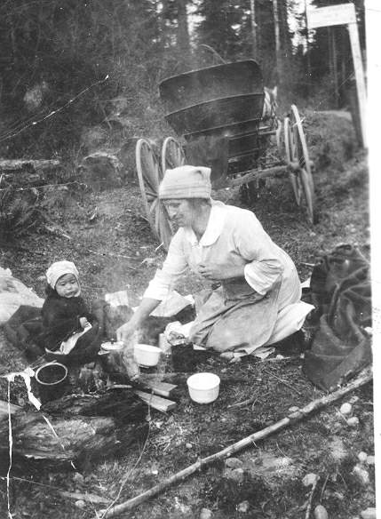
The morning session of the first day of the gathering will be set aside to honor our elders. Our drums and singers will share songs from our homelands. Many elders have come down from First Nations to join their brothers and sisters from the western Washington Tribes so they could enjoy story telling about their lives, land and water they have shaped their lives. Our elders will share their wisdom and direction for shaping policy of the Salish Sea Region.

As we look around the room we will see leaders from generations that have fought for our land and waters. Stories will be shared and history be told. Much of the history of the Salish Sea cannot be found in books, encyclopedias, and museums or on the Internet. The truth remains engraved in the memories of those who have lived it, the Elders.

We have planned the morning for them and hope they know that they are in our hearts. We are very thankful for them and for everything they do for us now and have done for us in the past.
“Our Ancestors before us leave us living in a new age, but their traditional markers run in our blood like the rivers flow into the ocean. The smell of cedar, saltwater, and smoked fish reminds us of whom we are. We continue to endure, adapt, and change through each decade of challenges, as did our forefathers.” By Yvonne Thomas-Miller Lummi Tribe

Keynote and special Speakers
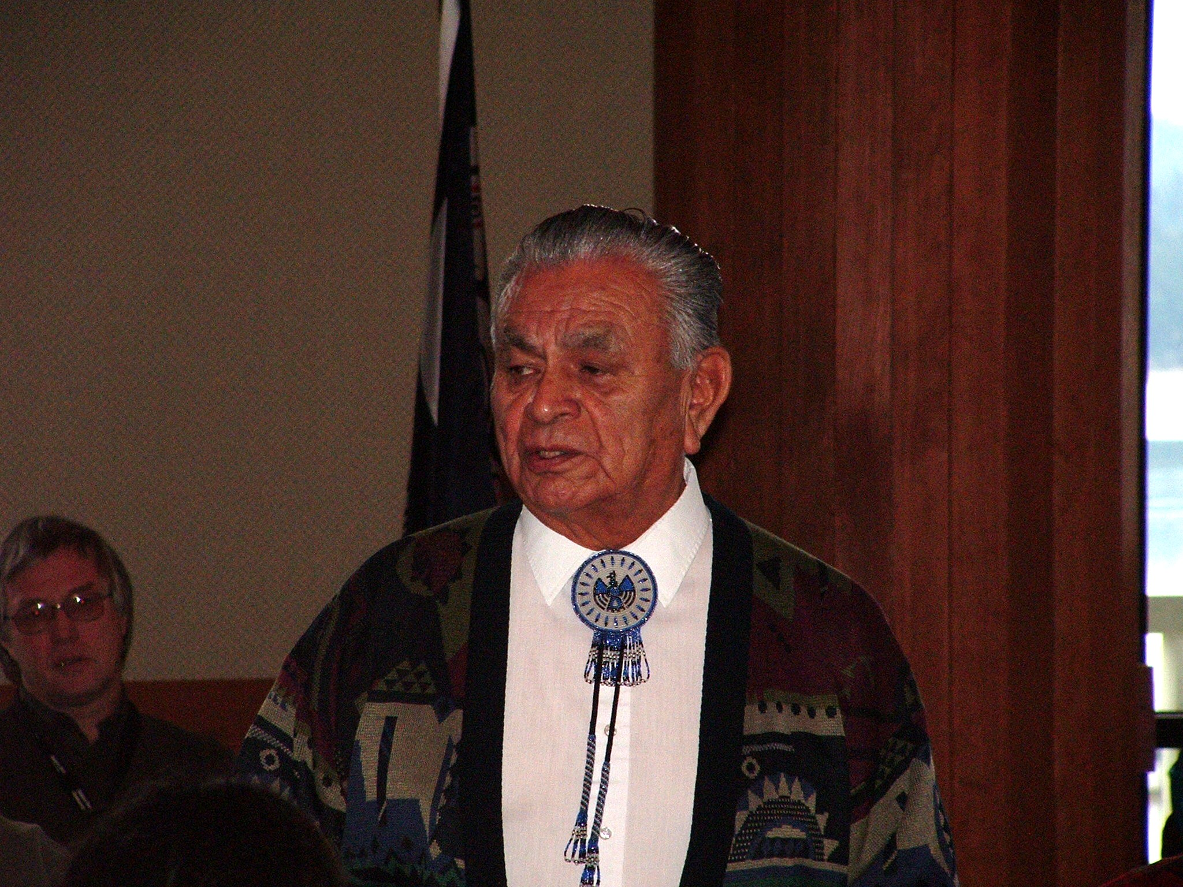
Tom Sampson, Coastal Salish Initiative, Saanich Inlet
Outgoing GSA director Tom Sampson has lived all his life on the shores of Saanich Inlet. His family’s tradition is that the first born always goes to the grandparents—a way of ensuring that the new generation gets a solid grounding in traditional knowledge. As the eldest of 12 children, Tom was raised by his great grandmother, a remarkable Halalt woman who had raised his father before him.
He describes her as “the lady who taught me everything”. In her 80’s when two-year-old Tom came to live with her, she taught him history, his place in the world, spiritual beliefs and all about the natural world, in both languages of the Coast Salish, her own Halkomelem (Cowichan) and her husband’s Sencoten (Saanich). No one knew her exact age, but baptismal records showed she was over 120 when she died about 30 years ago.
This focus on cross-cultural awareness has been evident in other environmental work that Tom has tackled. A few years ago he played a key role in getting the BC Environmental Assessment Office to undertake a ground-breaking Aboriginal Land Uses Study within the Bamberton Environmental Assessment, which documented traditional knowledge from elders and others from the Saanich tribes; it was done in the traditional language and then translated into English.
Tom believes that listening is the key to understanding the environment. He remembers his great grandmother telling him to go down to the beach and listen to the ocean, because “if you don’t listen to it and hear the stories, you won’t learn”. Listening to each other is just as important to Tom, and he believes this skill is not being taught to most young people today.
But spiritual beliefs form the heart of his environmental philosophy. “Conservation and management of resources are inseparable from these,” he says. “If you don’t see the spiritual need for the land and water, then people will continue to dump raw sewage, log mountains, and devastate the streams beyond repair. We have to look at ourselves. We can’t be holistic without a spiritual connection to the land.”
Tom has been a vital key to the success of the Coast Salish Gathering. His knowledge in the Coast Salish life ways has been instrumental in the direction and efforts of developing the life of the gathering. We, the Coast Salish Gathering Committee, value his time and trust and look forward to many Gatherings to come.

Billy Frank Jr, Chairman, Northwest Indian Fisheries Commission, Nisqually Indian Tribe
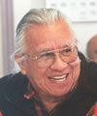
Billy Frank, Jr., has spent much of his life advocating for human rights for all, particularly the Indian people of western Washington. A Nisqually Tribal member, Frank grew up fishing for salmon and steelhead on the Nisqually River, and he was on the front line when the battle over treaty-guaranteed Indian fishing rights erupted in the 1960s and 70s. His perseverance landed him in jail more than 40 times, but they also helped guarantee Indian fishing rights when the Boldt Decision was made in the late 1970s. Cooperation not confrontation is what Frank advocates now. As chairman of the Northwest Indian Fisheries Commission, Frank has worked to achieve a number of key agreements between the tribes and various local, state and federal officials that further strengthen treaty-guaranteed fishing rights and environmental protection laws. His involvement in arenas like the unique Timber-Fish-Wildlife Agreement, the Chelan Agreement (a water resources planning document), and the Centennial Accord, have placed Frank in a powerful leadership role for Indian and non-Indian alike. It’s a leadership role that has been recognized from Olympia to Washington, D.C.
Who We Are, by Billy Frank, Jr., NWIFC Chairman
For many years, the tribes of the Pacific Northwest have advocated positive relations with the non-Indian community. It’s an historical fact that the footholds established by European and American settlers here would not have succeeded without our help. Our desire to be good neighbors continued through the years. People today are often amazed when they realize the level of pain tribes have received in return for their neighborly ways. But we’re still here, and although we fight if cornered, positive and effective government-to-government relations remain one of our top priorities.

That’s just who we are.

Two centuries ago, we fed those who came seeking fortunes in pelts, minerals and other natural resources, even though their descendants would ultimately cut up our lands. We brought fish to fledgling farmers, even though the industries they developed would ultimately dam our rivers and leach poison into the sea. We brought clams and venison to the budding merchants, even though their government took our children away and their cities soon crowded us off our traditional homelands.

That’s just who we are.

In my lifetime, I was arrested many times for exercising rights guaranteed by treaty with the government of the United States, yet I served as a U.S. Marine in the Korean War. Tribal members have sacrificed more lives and limbs per capita in U.S. foreign wars than any other ethnic group.

Today, my message to you is the same. I open my arms to you on behalf of my people and on behalf of the salmon and other resources that sustain us. I come to you with many concerns, and I do it with an open heart. It is time for you, whoever you are, to look around you and to realize that the ability of this land to sustain the continued onslaught of manifest destiny is at an end. The population has grown too much. The conversion of natural areas into concrete roads and cities is taking too large a toll. The poisons in the water are too lethal. The impacts of wanton takings are too severe. The footsteps of western society on this land are too heavy of a burden for it to bear.

That doesn’t mean we want you to go away. You are here now and that makes you part of the land. But the time is now to look beyond your cars and houses and realize that your home is your watershed; your responsibility is to respect and care for it, as you would your mother. Meaningful responses to overuse and pollution, climate change and salmon decline are limited only by our ability to work together toward common solutions.
In the words of a great chief, we are all connected. Our arms, as always, are open to you. We want to be good neighbors. Now, as always, we value the spirit of humanity – and that is who we all are.

Clarence Alexander, Co Chair, Yukon River Inter Tribal Watershed Council
"You know what I want? I want clean water. It's as simple as that."
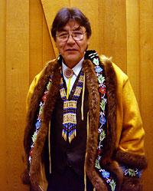
Clarence Alexander is honored as the recipient of the 2004 Buffett Award for Indigenous Leadership for his many years of work advocating for environmental justice, tribal rights and protection of the Yukon River Watershed. He is a respected leader with indigenous values, strong coalition building skills and extraordinary vision. Alexander is Dranjik Gwich'in and lives in Fort Yukon, Alaska.
As one of the Yukon River Inter-Tribal Watershed Council's four founders, Alexander oversaw the coming together and consensus decision-making of sixty sovereign governments bound together by treaty. The council has worked to clean up solid wastes, introduce recycling in over forty Native communities and institute a program of river monitoring on the Yukon. In addition, the council has effectively pressed the U.S. Department of Defense to begin clean up of several military contaminant sites in Alaska.
As a co-founder of the Yukon River Inter-tribal Watershed Council, Alexander advocates for clean up of the Yukon River and its tributaries, including Canada. The Yukon River is one of the largest watersheds in North America. Its headwaters are in the mountains of British Columbia and it empties into the Bering Sea.
Alexander is also a co-founder of the Council of Athabascan Tribal Governments. The council localized management of inter-tribal regional programs including natural resource management and tribal health funding. This localization resulted in improved health care, increased tribal oversight of federal land management and greater control of programs such as housing, education and environmental quality.
As former Grand Chief of the Gwich'in peoples, Alexander gathered seventeen tribes to discuss oil development's threat to the caribou and Gwich'in people. Discussion of these threats generated a unified stand of Tribal Chiefs on oil development in the region and increased awareness of threats to community quality of life in the Yukon River Watershed. Alexander also appointed spokespersons to the concurrently formed Gwich'in Steering Committee to address oil development. That committee continues to influence Congress with respect to concerns about oil exploration in the Arctic National Wildlife Refuge.
Alexander is currently Chairman of the Gwichyaa Zhee Corporation. He has served on the River Network Board since 2001 and was on the Board of the Alaska Humanities Forum. Alexander served as the Chief of Fort Yukon from 1980 to 1994. He is a founder of KZPA 900 AM Gwandak Radio and served as Chairman in the 1990s. In recognition of his leadership, the Institute for Tribal Government at Portland State University interviewed him to become part of the Great Tribal Leaders curriculum.
Alexander worked for the Alaska Department of Fish and Game for twenty years. He also served for sixteen years in the National Guard. Clarence and Virginia Alexander are nearing completion of their work on a Gwich'in Athabascan-English dictionary.

Harold Gatensby, Co Chair, Yukon River Inter Tribal Watershed Council

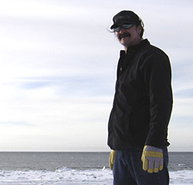
Harold Gatensby (Dahka T'lingit) is an honored 2006 Buffett Award finalist for his advocacy efforts to protect the Yukon River Watershed and his work within the justice system for better treatment of Native people. Gatensby is one of the co-founders of the Yukon River Inter-Tribal Watershed Council (YRITWC) and currently serves on its Executive Committee. He has also worked as a community-based justice training facilitator. Gatensby resides in Carcross, Yukon Territory, Canada.
As a co-founder of the YRITWC, Gatensby advocates for the clean-up of the Yukon River and its tributaries, one of the largest watersheds in North America. The coalition of indigenous governments of the YRITWC are indigenous citizens dependent on the environmental integrity of the Yukon River for survival; they unite on issues related to the environmental and cultural integrity of the entire watershed. Gatensby traveled to South Africa to represent the YRITWC at the 2002 United Nations Earth Summit.
Gatensby has been a keynote speaker at numerous events including the Alaska Federation of Natives annual meeting. He served as the Yukon Territory representative on the Advisory Board to the Aboriginal Justice Learning Network in Ottawa, a Canadian federal government-appointed board. He was instrumental in the creation of the Southern Lake Justice Committee in the early 1990s and served on the Committee in various capacities.
In 1995, Gatensby founded Nares Mountain Wilderness Camp, which he still owns and runs today. At the retreat center, Gatensby facilitates restorative justice and environmental trainings for individuals, community groups, and professionals from around North America. Gatensby's application of community-based justice (also known as circle sentencing) and indigenous T'ingit cultural traditions helps address the poverty, pain, violence and cycle of loss in his community as a result of residential schools and related institutions that were imposed by the Canadian government on his people.
Gatensby's personal history informs his community justice work. Memories of boarding schools for many First Nation generations recall pain and mental suffering. Youth incarceration is one symptom of this history. Gatensby is one face among the statistics. Spending many years of his youth in the prison systems, Gatensby made a conscious decision to turn his life around and help other people. He is now a respected House Leader of the Kookhittaan clan of the Dakha T'lingit Nation and on the front lines of community and environmental stewardship. Still, Gatensby regularly returns to correctional facilities to help inmates. He works tirelessly within the justice system for better treatment and cultural respect for Native people, cultural mediation and peace keeping.
In 2000, Gatensby received a Probation 2000 (three-day international conference) Individual Merit Award for his community justice work, presented by Her Royal Highness Princess Anne of the United Kingdom. This Award brings recognition to individuals who have developed innovative approaches to reducing crime in their communities. In 2004, Gatensby and his wife received the Cultural Volunteers of the Year Award from Carcross Community School. He is the proud parent of thirteen children.

Fay Cohen, Professor, Dalhousie University
Dr.Fay G.Cohen is a professor at the School for Resource and Environmental Studies at Dalhousie University in Halifax, Nova Scotia. She studied at Harvard (AB, MEd) and the University of Minnesota (PhD). She has lived and worked on west and
east coasts of North America. She is the author of Treaties on Trial: The Continuing Controversy Over Northwest Indian Treaty Fishing Rights (University of Washington Press l986,with contributions from J. LaFrance, V. L.Bowden,
Introduction by A. Fernando)and co-author (with A.J. Hanson) of Community-Based Resource Management in Canada: An Inventory of Research and Cases (Canadian Commission for UNESCO, l989) as well as book chapters and journal articles. She recently served (with P.Doyle-Bedwell) on the Environment Panel of the Policy Research Secretariat-Social Sciences and Humanities Research Council of Canada 's Project on Trends. At Dalhousie, she teaches Research Methods in Environmental Studies, Environmental Education, and a seminar on Indigenous Peoples and Natural Resource Issues.

Order of Business
SCHEDULE OF EVENTS

We invite you to the second Annual Coastal Salish Gathering in Duncan, B.C., the Hul qumi’num Treaty Group and the Cowichan Tribe at the Qutwusen Cultural Center, on January 24-26, 2007.
Following the traditional protocols of our ancestors, we invite you to sit and talk with your sisters and brothers to develop environmental policies for the long-term sustainability of our cultures and our homelands.
We, the aboriginal leadership at this important time in history, recognize this gathering as a forum of Tribes and First Nations of the Salish Sea Region that will explore issues, set directions and solidify our purpose in one voice,
“To develop and recommend policies and actions to protect our Salish Sea homeland.”
We have invited First Nation and Tribal Leaders of the Salish Sea to participate in this Policy Dialogue. Your role as a leader/ policy maker at the conference is to collaborate with those around you, and as leaders, identify environmental issues establish policy recommendations that will generate long-term actions to protect our homeland.
We have invited the Washington and British Columbia government officials to listen, respect, and respond to our environmental issues, decisions and recommended polices.
We will be heard as a collaborative voice in one room.
We will call on knowledgeable leaders to initiate the discussions, but the floor will always be open for your voice. This is our time to set policy together; this is the time to strengthen our voice as One.

Coast Salish Gathering
Yesterday, Today and Tomorrow
Duncan, BC, Canada
January 24, 25, 26, 2007

HOST TRIBES: Cowichan Tribe and Hul’qmni’num Treaty Group
LOCATIONS: Quw’utsun’ Cultural and Conference Center

PARTICPANTS (INVITED)
Coast Salish British Columbia First Nations, western Washington Tribal Government Chiefs, Chairmen, Senior Leadership Representatives and technical staff: Environment Canada, US Environmental Protection Agency, related Canadian and United States state, provincial and federal agency representatives, Coast Salish First Nation and Tribal environmental groups and related environmental organizations.

Meeting Objectives:
- Partnership Signing Ceremony, solidifying the commitment to protecting the Salish Sea Eco Region.
- Discussion of the Coast Salish Aboriginal Council.
- Discussion of strengthening and improving our relationships and the importance of shared policy development between all government entities.
- Discuss and identify Coast Salish environmental issues and actions with the intent of strengthening the Partnership.
- Identify 2007 Environmental protection goals and discuss common actions from existing policies and development of a Salish Sea Action Plan that will protect the Salish Sea Eco Region.

Notes: There will be several concurrent presentations on the 25th. A schedule of the presentation will be available on the 24th, and information table.

Agenda OVERVIEW |  | Participants
January 24, 2007 | A Day of Welcoming, Ceremony and Celebration, Quw’utsun’ Cultural Center | All Invitees
7:30-8:30 a.m. Breakfast and Viewing of the Documentary, Teaching of the Tree People

9:00-9:15 a.m. Invocation

9:30-10:00 a.m. Welcoming Address, Cowichan Tribe

10:00-11:45 a.m. Introductions from Coast Salish Invitees, Elders, and Honorary Speakers, and guest. Time for all leadership to introduce themselves and their homelands.

11:45-12:15 pm Introduction and Invitation to the Cowichan 2008 North American Indigenous Games
- Chief Harvey Alphonse, Cowichan Tribes & Rick Brant, CEO Cowichan 2008 North American Indigenous Games

12:15-2:15 p.m. Luncheon; hosted by the Cowichan 2008 North American Indigenous Games Society Cowichan-----2008 North American Indigenous Games: Announcement of first official corporate sponsor.

2:15-2:30 p.m. Special Presentation to BC Deputy Minister, Don Fast
- Honoring Deputy Don Fast for his past accomplishment as the Chairman of the Georgia Basin Steering Committee, Environment Canada. Mr. Fast was a champion to the Coast Salish efforts and a friend who strengthened the partnership to protect the environment of the Salish Sea Region.

2:30-2:45 p.m. Introduction of Pradeep Kharé, Director General, Pacific and Yukon Region, Environment Canada

2:45-3:30 p.m. Group Photo: Coast Salish Gathering, we respectfully request a photo opportunity in traditional wear.

3:30-4:00 p.m. Invitations and Announcements: If you have announcements please notify Clinton Charles, HTG, 250-245-4600

3:30-4:45p.m. Partnership Signing Ceremony, Brian Cladoosby, Chairman, Swinomish Indian Tribal Community
- The Partnership Ceremony will be a living symbol of solidifying the shared efforts of protecting the environment in the Salish Sea Region and strengthen the partnership oft the four governments; Coast Salish First Nations and western Washington Tribes, Environment Canada and US Environmental Protection Agency and other related agencies.

6:00-9:00 p.m. Dinner and Evening Events

- Keynote Speaker: Former Grand Chief of the Gwichin Zyee Clarence Alexander, Ft Yukon Tribe, Harold Gatensby, Dahka Tlinit Nation, Yukon River Inter Tribal Watershed Council Steering Committee

    - Alexander and Gatensby share their experience and strength with the Coast Salish, and will extend their helping hands to assist us in our Coast Salish Gathering.
      - Yukon River Inter Tribal Watershed Council is an indigenous grassroots organization dedicated to the protection and preservation along the Yukon River. The 64 indigenous Tribes and First Nations Council was created in 1997 by the indigenous communities along the Yukon River from Yukon Territory, Canada to the Alaska USA. They share their common grounds of protecting their homeland with one voice.

- Special Presentation: US EPA Deputy Administrator, Ron Kreizenbeck
    - Honoring US EPA Deputy Administrator, Ron Kreizenbeck, for the past accomplishments in protecting the environment and strengthening the partnerships with the western Washington Tribes.
    - Introduction of Elin Miller, Regional Administrator, US Environmental Protection Agency

Primary Contact Information Ray Harris, 250-245-4660

January 25, 2007  Meeting Day – Outcomes:  1. Identification of effective partnerships in environmental policy development and process in the Salish Sea Region  2) Identification of various policies and how the absence of Coast Salish participation has immediate and long term effects on the Coast Salish lifeways.  3) Identification of common grounds from existing policies and treaties to be used to implement into each individual governments environmental plans.  4) Identification and discussion of “common gronds”Salish Sea Regional Environmental Actions from the 7 policies, agreements and treaties discussed. Discussion of possible options of developing a shared environmental action plan for the Salish Sea Region. | Plenary Session  7:30-8:30 a.m. Breakfast and Viewing of the documentary, Yukon Circles  8:30-8:45 a.m. Opening Invocation: Cowichan Tribes  8:45-9:00 a.m. Opening Remarks: TBD  9:00–9:15 a.m. Welcoming Address and Introduction of Speakers: TBD  9:15-9:30 a.m. Welcoming Address – M. Brian Cladoosby, Chairman, Swinomish Indian Tribal Community  9:30-10:00 a.m. Keynote Speakers: Billy Frank Jr, Chairman, Northwest Indian Fisheries Commission  10:00-10:30 a.m. Keynote Speaker: Professor Fay Cohen, Dalhause University, Nova Scotia  10:30-10:45 a.m. Break  10:45-11:00 a.m. Summary of 2005 Coast Salish Gathering, Tom Sampson  11:00-11:15 a.m. Discussion: The Coast Salish Aboriginal Council, Terry Williams, Tulalip Tribe and Ray Harris, Hul’qumi’num’ Treaty Group  11:15-11;45 a.m. Witness Testimony  11:45-1:20 p.m. Lunch and Keynote (keynote: 12:45-1:15 in room)  Keynote TBD  1:15-2:00 p.m. Discussion on Strengthening Partnerships – Coast Salish Leaders discuss the importance of building effective partnerships through defining roles in policy development and process with federal, provincial and state agencies.  - Defining effective consultation and engagement with one another in our own respectful policy development processes.  - Dialogue Lead: TBD  - Identifying tools to improve coordination and communication between the Coast Salish, federal, provincial and state agencies.  - Dialogue Lead: TBD  - Discussion of the development of an annual Coast Salish Gathering that provides a policy platform for the governments in the Salish Sea Region, the Coast Salish First Nations and Tribal governments to dialogue and develop common grounds on environmental policy, programs and projects in the Salish Sea Region.  2:00-3:15 p.m. Improving Our Partnerships –Engaging the Salish Sea governmental bodies; Coast Salish, federal, provincial, state and agencies leadership, in identifying existing or proposed trans boundary environmental policies and recommendations that provide common grounds for all five governments to implement in their individual environmental protection plans and projects.  - Dialogue Lead: TBC—recommended DL listed below  - Identify the objectives and in participants in environmental trans boundary agreements and polices affecting the Salish Sea Eco Region, and discuss the Coast Salish role in current environmental policy development and processes impacting the Salish Sea.  - Declaration-Xwe-nal-mewx  - TBD  - Joint Statement of Cooperation  - Ron Krizenbeck, EPA and Marybeth Berube, EC  - TIPI, Treaty of Indigenous Peoples International  - Terry Williams and Alan Parker  - Pacific Salmon Commission Treaty  - Lorraine Loomis and Terry Williams  - British Columbia/Washington Environmental Cooperation Council  - TBD  - Puget Sound Partnership  - Mike Grayum, NWIFC  - Georgia Basin Action Plan  - TBD  3:15-3:30 p.m. BREAK  3:30-4:15 p.m. Identifying collective actions and recommendations from existing agreements, policies and treaties to protect the Salish Sea Eco Region with the intent of finding common ground for actions and recommendations including a discussion of the role of the Coast Salish Aboriginal Council in these processes.  - Dialogue Lead and Panel: TBC—recommended panel listed below  - Identify key policy processes for these the trans boundary agreements, policy, or treaties that include the Coast Salish First Nation and Tribal governments, state and federal agencies. How can we improve the effectiveness of existing policies and the implementation of recommended actions between separate governments of the Salish Sea?  - Declaration-Xwe-nal-mewx  - TBD  - Joint Statement of Cooperation  - Ron Krizenbeck, EPA and Marybeth Berube, EC  - TIPI, Treaty of Indigenous Peoples International  - Terry Williams and Alan Parker  - Pacific Salmon Commission Treaty  - Lorraine Loomis and Terry Williams  - British Columbia/Washington Environmental Cooperation Council  - TBD  - Puget Sound Partnership  - Mike Grayum, NWIFC  - Georgia Basin Action Plan  - TBD  - How can we link all of these action and recommendations from the 7 policies, actions and agreements into the protection of the Salish Sea?  4:15-5:00 p.m. Witness Testimony  - Wrap up and Summary of the Day’s Discussion  - Facilitator: Terry Williams, Tulalip Tribe and TBD, HTG  7:00-9:00 p.m. Dinner and Cultural events  - Keynote: Robert Morales, Chief Negotiator L.L. B, Hul qumi’num Treaty Group  - Traditional Dancers and Cultural Events | All Invitees  Day 1 Speakers:  US Speaker:  Brian Cladoosby, Chairman, Swinomish Indian Tribal Community  First Nation Speaker: Chief Marion Chapman  Morning Witnesses:  US Witness: TBD  FN Witness: TBD  Afternoon Witnesses:  US Witnesses: TBD  FN Witnesses: TBD
January 26, 2007 | Day 3
8:30-8:35 a.m. Opening Invocation –Cowichan Tribde

8:35-9:00 a.m. Day 2 Summary and announcements of Concurrent Sessions

9:00-12:00 p.m. Concurrent Sessions
 | Concurrent Sessions: 9:00-12:00 p.m.
TRACK 1:
9:00-11:45 am: OPTIONAL If recommended from the Coast Salish Gathering Leaders, an optional working session for policy review and recommendations for the a Salish Sea Environmental Plan that would consist of the “common grounds” from the seven policies, agreements and treaties.

Work Session: Identifying, reviewing and discussing Day 2’s Gatherings recommendations and actions from the government leaders from Day 2, and determining the next step and options of common grounds.

Track 2: Technical Working Tools Facilitator: TBD
9:00-10;15: Water Resources and Management Tools
- Tulalip Tribe: Shoreline Management on the Reservation with regards to environmental protection of the fisheries management due to the impacts of population, industrial and home growth. (Refer to Daryl, Bill and Cyrus)
  - Refer to Tribal Roles in Washington Land Use
  - Growth management, shorelines management and fisheries resource management
10:15-10:30: Break

10:30-11:15 Trans Border Data Collections and Sharing:
- Gathering and building a data base that identifies Coast Salish Environmental programs and projects, supports data development and sharing, as well as, networking communications and policy information. How do we get there?
11:15-11:45 Wrap Up and Summary
 | 12:00-1:30 p.m. Lunch and Closing

Policy dialogue points from the 2005 Coast Salish Gathering

Salish Sea Gathering

Sharing Environmental and Natural Resource Issues in our Homeland, the Salish Sea Region

Slide 1: Session 2 - Issues Identification

Overarching Issues

Governance Issues

Capacity Issues

Development Issues

Slide 2: Over-arching Issues

Long-term sustainability of our culture

Impacts of Climate Change/Global Warming

The negative effects of diminished habitat and marine resources on the traditions and life ways of Tribal and First Nations people

Slide 3: Governance Issues

Multi Trans boundry Governments managing the one eco- system-Salish Sea Region

Meaningful roles for First Nations and Tribes in Policy Development

Development of policies and regulations with limited or no consultation with Tribes and First Nation

Slide 4: Governance Issues Continued

A goal of the Joint Statement of Cooperation (SOC) on the Georgia Basin/Puget Sound Eco System – “to engage Tribes and First Nations in setting future priorities”

How were Tribes engaged in the the Draft Puget Sound Salmon Recovery Initiative

Slide 5: Governance Issues Continued

Co Management

What works / what doesn’t

Incorporation of Traditional Resource Rights and Customary use in the Management of Shared Resources

Slide 6: Governance Issues Continued

IIncorporating Traditional Ecological Knowledge in the development of conservation and management plans

Review existing mandates and regulations to better fit existing governmental relationships and changing ecological conditions

Slide 7: Governance Issues Continued

MPA

The imposition of Marine Protected Area policy on treaty and traditional resources

Slide 8: Capacity Issues

Increase cross border communications on environmental/habitat issues between First Nations and Tribes

Secure Networking tools for First Nations and Tribes to collaborate on issues and projects in the Salish Sea Region?

Comprehensive database of Tribal and First Nations Issues and Projects

Stop and Go Funding Sources

No long term funding for programs

No long term action plans

EPA Funds Capacity Building but not Implementation

Slide 9: Capacity Issues Continued

On going cost of maintaining the level of staff and the training required to run an efficient and effective environmental program

Public Education Program that shares the importance of the Natural Resources to Tribes and First Nations survival in today’s world

Slide 10: Capacity Issues Continued

Government Staff Training

Incorporate cultural sensitive protocols for Government Staff to follow when working with Tribes and First Nation

Retaining Funding and Capacity to protect Mother Earth

How can we continue to cut Northwest Fisheries funding, 80-90% in the last 30 Yrs, and still think we are safely protecting the habitat?

Healthy Habitat = Salmon Survival

Slide 11: Development Issues

Development Impacts outdistance conservation/restoration efforts

Incorporating new interventions in environmental projects

Tulalip Waste Water Recycle Project

Develop guidance from Tribes and First Nations to protect nearshore habitat and functions-an innovative approach

Slide 12: Development Issues Continued

Growing populations pressures

Impacts on water quantities

Depletion of instream flows effecting fish and habitat

Dependence on an economic system that requires continued growth and expansion

Degraded water quality from poor storm water and waste water management

Victoria Sewage

Failing onsite sewage systems

Slide 13: Development Issues Continued

An Assessment of water and air Trans boundry pollution movement and fate

River Systems

Frasier River

Skagit River

Marine Waters

Diesel Emissions

Agricultural run-offs

Bio-accumulative Toxics in marine life

Slide 14: Development Issues Continued

Health Risk Assessments

Not sensitive to indigenous lifestyles

Summary of 2005 Coast Salish Gathering

A. History and Background

A historic gathering of Coast Salish Leaders, representatives of United States and Canadian Governments, and environmental organizations convened at the Jamestown S’Klallam Tribal Community Center. The Gathering brought the Coast Salish Leaders of the highest level of government, the First Nation Chiefs and representatives from British Columbia and the Western Washington Tribal Chairmen and council members together to express their environmental concerns on problems confronting the Salish Sea region and the long-term sustainability of their cultures in the shared eco-region that has supported their lifeways for thousands of years.

Participants met to discuss the need for increased protections for the Salish Sea’s rich marine diversity and other resources unique to the area that stretches from the Georgia Basin, down through the Puget Sound and the Straits of Juan de Fuca. These diminishing resources are essential to sustaining the cultures, economies and homelands of the Coast Salish Tribes and First Nations whose aboriginal cultures are under significant pressure from population growth, industrial expansion and climate change that are affecting the viability of the Georgia Basin/Puget Sound eco-region. The Salish Sea Gathering was an extended aboriginal policy dialogue regarding tribal environmental issues, policies and projects in the trans-boundary region. Participants discussed the need to collaborate in determining the impacts and human responses that shape the state of this shared eco-region. The Gathering’s objective was to provide government officials with the perspectives of the indigenous leaders and representatives of the region regarding the future of the fragile Salish Sea so as to better inform decision makers and the decision making processes they administer.

The ongoing collaborative efforts of Tribes and First Nations to protect their diverse eco-region is reflected in the jointly developed Treaty of Indigenous Peoples International in 1994. This Treaty was an initial step followed by the development of the Joint Statement of Cooperation on the Georgia Basin Puget Sound Ecosystem, which was signed January 2000, by the Minister of Environment Canada and the Administrator of the EPA. The Gathering signified the unity of Coast Salish Tribes and First Nations to further strengthen the sustainability of their homelands and their culture.

The Gathering was supported with funding from the Environmental Protection Agency, Environment Canada, Canadian Consulate, the Office of Indian Affairs and Northern Development, and the Coast Salish Tribes and First Nations. The efforts of the Swinomish Indian Tribal Community, Jamestown S’Klallam Tribe, Northwest Indian Fisheries Commission, Tulalip Tribes, and the Coast Salish Initiative coalesced to host, coordinate and facilitate this policy dialogue on the cultural and spiritual concerns impacting the Coast Salish People.

The government and municipal representatives were welcomed and asked to share their thoughts, issues and ideas to the assembly. Many representatives were moved by the spirit of the Gathering and were able to share knowledge and show commitment to the Georgia Basin Action Plan of “engaging Tribes and First Nations”. The testimonials of the Coast Salish Elders and leadership provided a unique opportunity for the governmental officials and environmental policy makers to hear how important the environment is incorporated into the Coast Salish life ways and their cultural survival.

The Coast Salish People stretch from north of the Powell River, down through the Georgia Basin and through the waters of the Puget Sound and the Strait of Juan de Fuca. The Coast Salish People live their life interdependent with the land, air and water and resources the ecosystems of the region provide. The protection of the environment is ingrained in their traditions and life ways. Their culture and existence depends on the fish running though the rivers and bays, the shellfish in the tidelands, the deer in the woods, the native plants for their medicine and the noiseless woods for their spiritual places. Without a healthy productive environment, their way of life has no foundation and will cease to exist. The importance of protecting the ecosystems of their homelands is a priority for Tribes and First Nations. If the denigration of the environment is allowed to continue, they risk the loss of their voice, bodies and souls.

The 2005 Gathering brought the Coast Salish Leadership together to discuss their shared environmental concerns and after two days of heart-filled testimony, the assembly of Coast Salish spoke with “One Voice”; the leaders of the Coast Salish resolved to form a list of prioritized environmental concerns and issues, the Coast Salish Inventory of Environmental Concerns. The leadership further extended their commitment to the continuity of protection for their homeland by establishing the Coast Salish Aboriginal Council, a podium for all Coast Salish Leadership to network and share environmental issues of their homelands.

Presently, there are a variety of treaties, environmental action plans and initiatives in the Puget Sound/Georgia Basin Region that are supported by either the US governments, Canadian governments and other non-governmental organizations. These plans, programs and initiatives include; the Puget Sound Partnership, EPA and EC Statement of Cooperation, Puget Sound Action Team, and Northwest Straits Commission; Marine Resource Committees, People for Puget Sound, to name a few. But none include comprehensive participation from all 26 Western Washington Tribes and 77 First Nations. Although most groups have included a Tribal representative to provide an aboriginal voice on their committee, comprehensive tribal representation is limited in the area of policy development for the protection of the ecosystems that are the foundation of their homeland.

B. Recommendations from the 2005 Gathering

Problem: Presently, there are a variety of treaties, environmental action plans and initiatives in the Puget Sound/Georgia Basin Region that are supported by either the US governments, Canadian governments and other non-governmental organizations. These plans, programs and initiatives include; the Puget Sound Partnership, EPA and EC Statement of Cooperation, Puget Sound Action Team, and Northwest Straits Commission; Marine Resource Committees, People for Puget Sound, to name a few. But none include comprehensive participation from all 26 Western Washington Tribes. Although most groups have included a Tribal representative to provide an aboriginal voice on their committee, comprehensive tribal representation is limited in the area of policy development for the protection of the ecosystems that are the foundation of their homeland.

Possible Goal: To coordinate and support the shared environmental protection efforts of the Western Washington Tribes and First Nations to ensure the preservation, enhancement and protection of the common resources of the Puget Sound Georgia Basin Environment.

Primary Strategy: The Strategy is to achieve the goals is for the Western Washington Tribes and First Nation to coordinate and develop shared policies and actions to protection their environment, to ensure the sustainability of their traditional resources, culture and life ways, to collaborate with those parties who share the common responsibility of protecting the Puget Sound Georgia Basin Region, and to maintain a progressive evaluation process that measures and adjusts the efforts as the needs of the environment change in time.

Elements: To provide a platform for Western Washington Tribes and First Nations to participate in a cooperative efforts to protect the Puget Sound Georgia Basin Region

- Coordinate with First Nations and western Washington Tribal Environmental Leads and Policy Makers to form a coalition to review and develop the a Coast Salish Gathering Environmental Action Plan from the Inventory of the Coast Salish Environmental Concerns and to develop and implement support tools for the process and Plan.
- Coordinate with First Nations and western Washington Tribes and Tribal organizations to expand and develop the Inventory of Coast Salish Environmental Concerns.
- Coordinate with First Nations and western Washington Tribes and Tribal organizations to develop, establish and implement a TEK outreach program/tool to support the Plan, Coalition, Tribes and Tribal Organizations.
- Develop a Tribal Outreach Communication process to provide a cross review and comments process for the First Nations and western Washington Tribes on a Coast Salish Gathering Tribal Environmental Action Plan.
- Develop a Non Tribal Outreach Communication process to introduce and support the Tribal Environmental Action Plan to federal, state, local and other organizations who share the common responsibility of protecting and restoring the Puget Sound Georgia Basin Environment.
- Establish a long term process to maintain and update the Tribal Environmental Action Plan as the demands and needs of the environments changes, to support the networking and communication of the Tribes and to ensure the Plan is implemented into all present and future action plans.

- Measuring Effectiveness

- The Coast Salish Gathering may establish a workgroup to support the efforts and to continue the evaluation of the Coast Salish Tribal Environmental Action Plan process and growth actions implementing milestone performance measures. The recommendations supports the process and adaptive needs of the Tribal Environmental Action Plan.
- The milestone measurements and reporting will be tracked through innovative techniques such as videography reporting, formal documentation to support a published written and video documentary.

The shared issues are categorized as the following:

C. Summary of the Policy Dialogue Points and Concerns from the 2005 Gathering.
- Overarching Issues
- Governance Issues
- Capacity Issues
- Development Issues

Over-arching Issues
- The continuation of the environmental degradation has caused and will continue to cause negative impacts the Coast Salish traditions, health and life ways today and for generations to come. The degradation of the environment is responsible for the loss of habitat and water quality, leading to the loss of traditional foods such as salmon, shellfish, elk, deer, berries and native plants used in traditional medicines.
  - Concern is the continued degradation of the environment will lead to the extinction of the Coast Salish life ways.
- The degradation of the environment has caused the depletion of natural resources causing a defestating effect to the Nations and Tribes hunting and fishing rights. Coast Sahlish should are tied to the the natural resources of the shared region; they have taken the initiative to collaborate to restore the habitat and natural sources.
  - Concern is the Coast Salish have rebuilt their capacity and are collaborating together to share policies and actions to manage and protect their environment; however these policies and plans have not been recognized nor adopted into some existing Georgia Basin Puget Sound Action Plans.
- The Coast Salish Tribes have been long tied together through bloodlines that stretch north of the Powell River and down through the Straits of Juan de fuca, and down the beaches of Makah and the coast of Quinault.
  - Concern is the Coast Salish culture has sustained burdens of disease, wars, death, and assimilation. They now face the degradation of their environment, and the threat of extinction of their tribal culture.
    - What tools were recommended to the long-term sustainability and protection the life ways.
      - Needed Tools
        - Language: The Coast Salish language supports the grass roots of their culture and provides the historical terminology and knowledge to support the Coalition and Plan. The Coast Salish language provides the guidelines of the families, governments, policies, health, and history.
        - Collaboration: The Coast Salish Tribes and First Nations are supportive of a common goal: to protect their environment, restore their rightful fishing and hunting habitats, and protect their cultural life ways..
      - Funding: Concern is the environmental funding cutbacks have affected the overall capacity, infrastructure and technical support.
Governance Concerns and Issues
- The Salish Sea is the only eco region that contains one aboriginal nation, the Coast Salish. They are the rightful landowners of the eco region and share the same environmental values, teachings and respect for the land, water and air. The historical lessons track back through traditional stories that has been taught through their generations and support the shared environmental teachings and natural resource management style, governance styles, family bloodlines and values.
  - Concern is the eco region is managed by multi trans boundary governments managing one, with difference environmental action plans, government styles, regulations and policies.
- The US and Canadian border and the governance issues has separated the alliance of Coast Salish Tribes and First Nations which has resulted in loss of the control of policy development in their homelands. The Coast Salish Tribes and Nations have restarted the alliance of knowledge, strength and support to regain their rightful place as the owners of the land, water and air of the shared eco region.
- One nation, one eco region, one policy, one plan
  - Concern is the US and Canadian government have existing ongoing trans boundary organizations, councils, committees, shared projects, polices and action plans that do not include participation from Coast Salish Nations or Tribes.
- The demands of the growing population, economy and industry weigh heavily on the Puget Sound Georgia Basin Environment. The water quality and quantity is failing to support the demands of the growth, and longer it takes for a settlement and policy to be agreed upon, the cloaser we come to depleting the water resources.
  - Concern is the need to recognize and prioritize the water quality and quantity environmental issues before they are completely depleted.

Capacity Concerns and Issues
- The US and Canadian Governments have established several agreements, task forces and action plans to manage and protect the Puget Sound Georgia Basin Region. The Coast Salish have built their capacity to maintain at the advisory level to assist the international, federal, state, local and organization policy makers in developing environmental policies and action plans.
  - Concern is the tribal representatives do not have the staffing or support capacity and a tribal consensus to fully represent the Coast Salish in the international, federal, state, local and organizational environmental policies and actions.
- The Coast Salish People have a traditional network of gatherings in the form of canoe journeys, potlatches, naming ceremonies, or spiritual ceremonies where leaders share information and process decisions based on their shared decision making process.
  - Concern is the present funding resources do not fund nor support the traditional gatherings and the shared decision processes.

- The Coast Salish Tribes and Nations have many successful environmental tribal projects and programs and are in need of a centralized host and storage tool that contains the projects and programs. With today’s technology, management and security capacity there is an opportunity to increase our shared efforts through a secure comprehensive database of Coast Salish Tribes and use the database to support and update the Tribal Environmental Action Plan. The future plans would be to collaborate First Nation and implement their environmental projects and programs into the database and use it to support their participation in a trans boundary Tribal Environmental Action Plan.
  - Concern is the lack of funding to support the staff to maintain the database and research and networking to support the database project.
- The Coast Salish Tribes have been building their capacity to manage their own environment and natural resources. The government agencies have provided funding capacity through the stop and go funding sources.
  - Concern is the funding resources do not provide implementation funding for those Tribes who have reached their capacity, long term planning and action planning limitations.
- Coast Salish Traditional Ecological Knowledge is product of the generations of learning and experience of the lands, water, fish, plants, wildlife, and other natural resources. The TEK contributes to several environmental areas; conservation, ecosystem management, governance and provides a balanced approach that can serve as a model to support the protection and restoration of the environment.
  - Concern is the Coast Salish TEK has not been incorporated into the Puget Sound Georgia Basin Region international, federal, state, local agencies and organizations policy and action planning.

- The collaborative efforts of the Western Washington Tribes have been evident in the success the Northwest Indian Fisheries Commission and its capacity and ability to protect and restore the salmon and its environment. If the funding cutbacks for NWIFC continue to occur, the Western Washington Tribes risk the loss of one voice and one warrior.
  - Concern is the funding cut backs are a negative effect on the collaborative efforts of the Western Washington Tribes and their efforts to protect the environment and natural resources.

Development Issues Prioritized
- The Coast Salish People have lived for centuries without a border across their lands; they shared their hunting and fishing rights depending on traditional family, land and bloodline rights. In the past 150 years the Canadian and US Governments have drawn a border that has divided the Coast Salish People and brought land, fish and hunting wars to a harmonized nation. The Tribes and Nations have rekindled their bloodlines through their traditional gatherings of canoe journeys, potlatches, naming ceremonies, and spiritual ceremonies; this has allowed them to strengthen their voices to support their political needs to protect their shared homeland. The rekindling of the Coast Salish People has brought the environmental protection issues into full speed; and the Tribes and Nations are struggling to share their knowledge, projects and programs. The shared efforts need to be developed into a stable program that supports trans boundary projects, policymaking, and protection of their homeland.
  - Concern is we are lacking the funding resources to support trans boundary environmental program.

- The Georgia Basin/ Puget Sound Region is rich in a diverse array of ecosystems and species unique to this area that sustain the life ways of the Coastal Salish Tribes and First Nations. Salmon are an excellent example of the integral and yet vanishing connection the people and their land.
  - Concern is as the shared homelands are under significant pressure from population growth, industrial expansion and economic demands.
  - .
- The Coast Salish People have shared the water ways of the shared eco region. The trans boundary pollution movement between the land, air and water is evident is several river systems, the Frasier River, Skagit River, and Marine Waters.
  - Concern is the Tribes do not have a developed network process or system to share environmental information.
- The Diesel Emissions policy making is not effectively managed by both US and Canadian governments; and the policies are a reflection on political willpower, rather than depending on the environment concerns.
  - Concern is the diesel emission’s policy making process is not environmentally friendly.

- Agricultural run-offs
- Bio-accumulative Toxics in marine life
- Health Risk Assessments
  - Not sensitive to indigenous lifestyles

Tools to Succeed:
- Consensus
  - The need to establish a prioritized list of shared issues, tools, and long term plan to protect and preserve our homeland’s environment and resources.
- Communication
  - Establish a means of an Ongoing Communication Network System
  - Use our existing system to come together
    - Gatherings
    - Families
- Collaboration
  - Shared Information
  - Joint Projects
- Language
  - Our Language is an essential tool that ties us to the our lands and our cultureUse our language to establish our rightful place at the table
- Funding
  - Long term planning
  - Sustainability

Sponsers
The two Salish Sea Gathering and ongoing work is supported in through several sources;
United States Environmental Protection Agency
Environment Canada
Other relevant agencies.

